The “Webspace” is the hosted filesystem.

Access the “WebSpaceExplorer” from the Control Panel ->Hosting-> . -> Launch. The WebFiles dialog appears

Inside of the Webspace, create a folder for each website.

So for the test website, the folder will be TestATAPConsusltingCom; for Production the folder will be wwwATAPConsultingCom

Domains and subdomains are created and administered by 1And1.

Domains and subdomains are assigned to webspace folders.

Domain ATAPConsulting.com and subdomain [www.atapconsulting.com](http://www.atapconsulting.com) are both assigned to webspace folder wwwATAPConsultingCom.

Domain test.atapconsulting.com are assignged to webspace folder testATAPConsuslting.com

1AND1 allows for “unlimited” FTP userids.

FTP UserIDS , once login occurs, point the root of their FTP directory to a WebSpace folder.

FTP UerID ftp49008251-1 is for access to the test webspace folder, /TestATAPConsultingCom.

After ensuring the webspace folder, subdomain, and FTP UserId/pwd are created and setup, the pages/code for the site can be deployed to 1and1

Visual Studio 2017 publish profile creation dialog box:

Server is home242383179.1and1-data.host

From the debug/development configuration, deploy the test website assets to the test webspace folder using the test FTP UserID / pwd.

FTP UserID [ftp49008251-0](ftp://ftp49008251-0) is for access to the test webspace folder, /TestATAPConsultingCom

Create the production release branch from master.

The first release is 0.1.0 (Major / Minor / Patch). The Build is the date, revision is number of times the build was done that date. The Package identifier is the Assembly (Website) name, . Major . Minor.Patch

Create the release branch from the mAster branch. Following is the VSIDE Team Explorer Branch View Create Branch dialog.

Change the version in the asemblyinfo.cs file

Build Release version

Verify the tests run.

Publish; create a new publish profile for production.

On Publish, verify no errors occur

Browse to production domain.

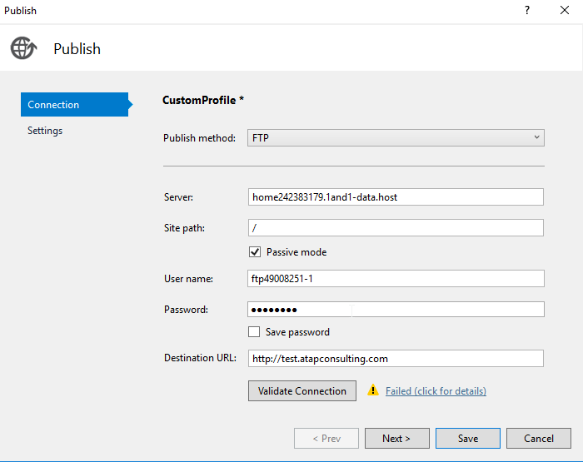

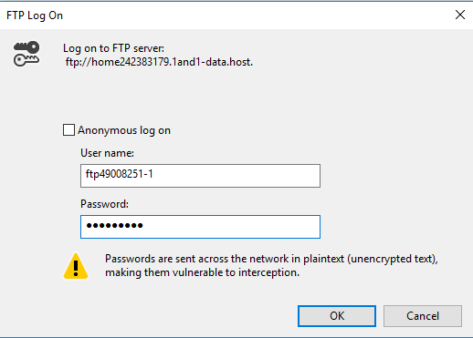

After entering correct Server, User Name, and {Password, a green checkmark appears in dialog

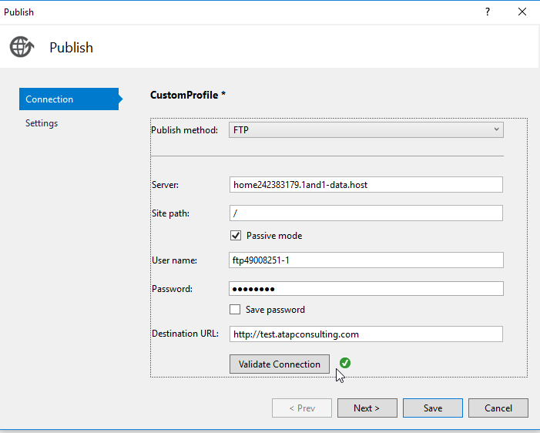

Next step will “save” the profile.

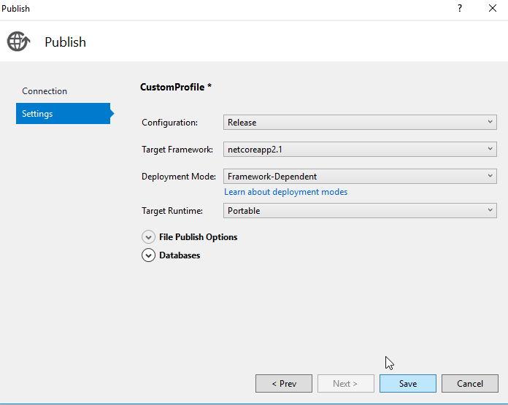

Now the Visual Studio Publish tab has a lot more information

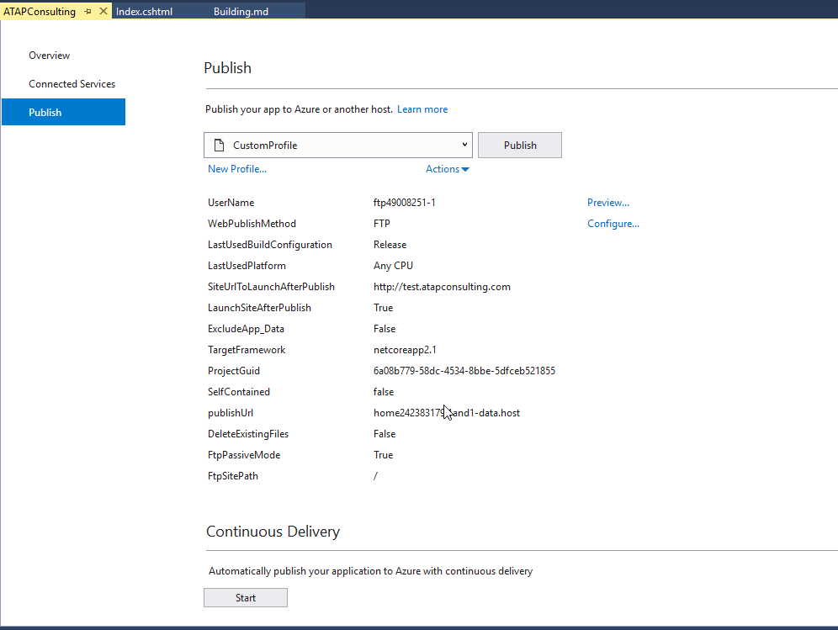

Now rename this profile

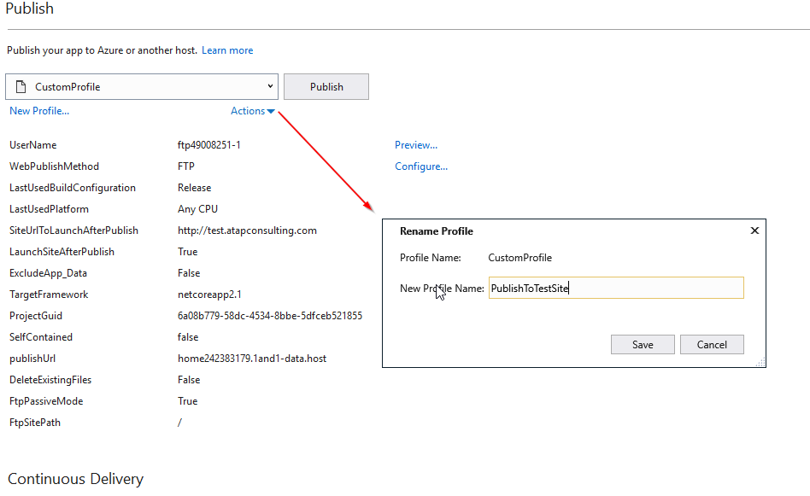

And the publish tab is now shorter

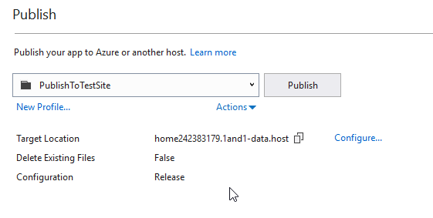

Pressing “publish” brings up the FTP login dialog (remember, do NOT save the password in the profile!)

Visual Studio Output windows shows a lot of lines as it prepares for, and the sends, the website up to 1And1

After publish, it opens a browser to test.atapconsulting.com, and the website appears.

